27.62: a) 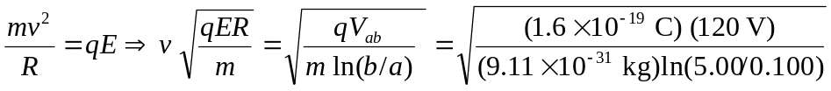
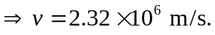
b) 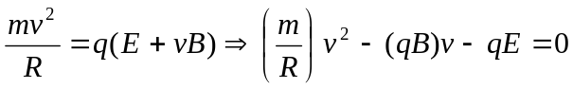
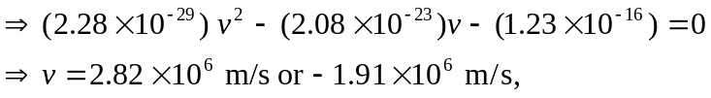
but we need the positive velocity to get the correct force, so v 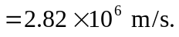
c) If the direction of the magnetic field is reversed, then there is a smaller net force and a smaller velocity, and the value is the second root found in part (b), 